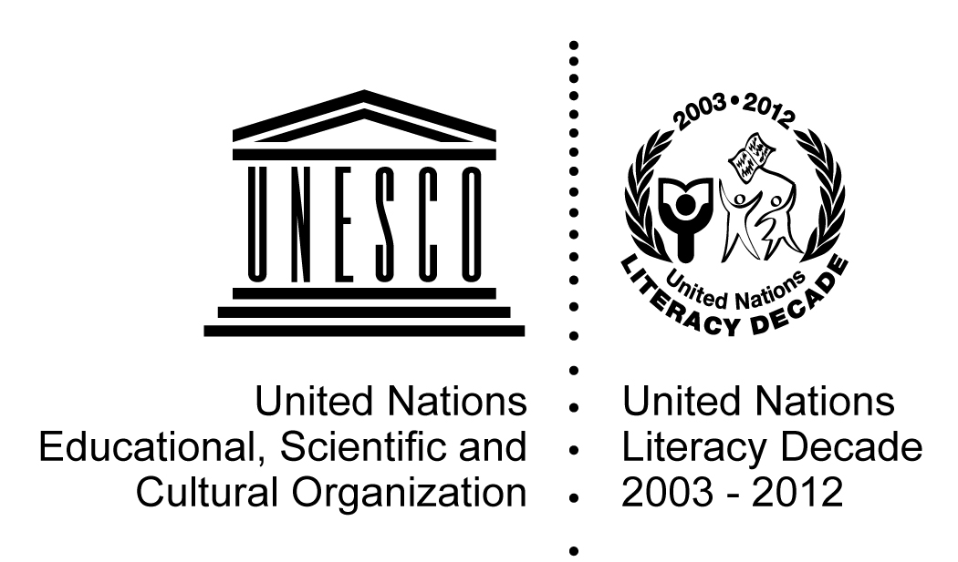 |  |  | UNESCO International Literacy Prizes 2014  Submission Form
1. Basic Facts
Title of programme/project:
Name of implementing organization:
Chief executive officer of the organization:
Country:
Starting year: Ending year: Ongoing:
Type of Organization: National Government National NGO International NGO Other National Institution
Other (Local branch of National NGO, Private body, Trade Union, Religious mission, etc.). Please specify
Operating in: Region Country District Province Community Other Please specify
Main partner(s):
2. Contact Details
Name of contact person:
Job title (or position):
Full Address: |  |  |  |  | Country:
Telephone/Fax: |  |  |  |  | Web site, if any:
E Mail:
3. Implementing Organization
Describe the organization, its history, its aims and mandate, its governance structure, any other relevant information (minimum 250 words):
4. Programme Summary
Describe the vision and rationale of the programme/project: the main goal and the particular problem/s it seeks to address (minimum 300 words):
5. Thematic Areas (tick those that apply)
Literacy and Rural Development
Literacy and Gender
Mother-Child Literacy and Intergenerational Learning
Literacy and Human Rights
Literacy for Health (i.e., Preventive health and HIV/AIDS, nutrition and hygiene)
Literacy for Economic Self-Sufficiency
Literacy and ICTs (including radio and TV)
Literacy in a multilingual context
From literacy to lifelong learning
Literacy and sustainable development
Other please specify:
6. Programme Details
a. Specific objectives |  | List and explain the specific objectives of the programme/project (150 words):
b. Outreach |  | Main target group(s): Adults (15 +) Out-of-school youth Women & girls Indigenous peoples Minority groups Other, please specify
 |  | Number of locations where the programme is running:
 |  | Number of participants reached annually:
 |  | Number of participants reached by the programme since its inception:
c. Programme delivery |  | Structure and mechanism
 |  | How are the courses organized? Please describe:
 |  | What is the duration of the courses annually?
 |  | What is the duration of the courses in total?
 |  | What is the average number of learners per group?
 |  | Are there accreditation mechanisms in place? Please describe:
 |  | Teaching-learning: methodology
 |  | How are the learners’ needs determined? Please describe:
 |  | What kind of teaching methodology is applied? Please describe:
 |  | Teaching-learning content and material
 |  | How is the content of the curriculum decided? Please describe:
 |  | What kind of material is being used?
 |  | What are the main topics covered? Please describe:
 |  | How and by whom is the material developed?
 |  | Programme facilitators
What is the profile of a typical facilitator? Volunteer Paid Full-time Part time
Other, please specify:
 |  | What is the learners/facilitator ratio?
 |  | What is the remuneration of the facilitators?
 |  | How are the facilitators trained?
 |  | Does the programme provide training of trainers? If yes, describe how:
 |  | Language(s) of instruction
 |  | Official language |  | Mother tongue |  | Other:
d. Use of ICTs |  | Are ICTs utilized in teaching or management of the programme/project? If yes explain how:
e. Funding | List and provide name of the main funding sources in order of importance:
e. Funding | Government
e. Funding | Private Sector
e. Funding | National NGO
e. Funding | International NGO
e. Funding | Foreign Donor
e. Funding | Self financed
e. Funding | Other (please specify):
f. Costs | Annual costs of the programme/project: (Local currency or USD )
 | Annual cost per learner:
g. Partners | Provide full list:
g. Partners | Provide evidence of commitment and support of the Government if any:
g. Partners | List contributions from the private sector and/or NGOs:
g. Partners | Other partnerships (please specify):
7. Programme Results
List and describe the achievements of the programme/project (minimum 150 words)
8. Monitoring and Evaluation (total minimum 200 words)
Do you undertake monitoring and evaluation of the programme/project during implementation? If yes, explain how:
Do you evaluate the outcomes of the programme? If yes, explain how:
Do you evaluate the impact of the programme? (i.e. on the quality of the learner’s life, his/her family and community. If yes, explain how:
9. Sustainability (total minimum 200 words)
Describe how the programme/project promotes sustainability (in terms of financial sustainability and/or local capacity to sustain the programme):
Is the programme/project being replicated elsewhere or scaled-up? Please describe:
10. Innovative Features
List and describe the innovative features of the programme/project (minimum 120 words):
11. Challenges and Constraints
List the main challenges and constraints encountered (minimum 120 words):
12. Additional Information
List any sources from which information regarding the programme/project is available:
13. Please list here documents in the following categories that will accompany this application
Documents, films, audio visual material available about programme:
Published research studies / reports available about the programme:
Internal or external evaluations of the programme, reports on impact assessments:
Teaching and learning material:

Date of submission form completion (MM/DD/YYYY):

